# Universal Language

### Mind Puzzles, Magic Systems, Character Balance and Storytelling

##### Tho’ra uses Universal Language to befriend robots, dragons and all manner of invasive creatures that have slipped in from the dimensional rifts left over from the Time Wars.

###### Players use **Universal Language** to solve puzzles and unlock how to use **Psi Abilities**.

#### Objective

### **Use Universal Language** to **Win** **Hearts**, **Sparks** and **Minds**.

### Master emotional intelligence scenarios that are supposed to otherwise be impossible using the magical language of friendship. *(Base12-typeH)*

###### “We have something better than cheat codes, we have source code: We can make our own cheat codes up!” - Jono Tho’ra

### A Universal Programming Language as a Universal Writing System

### **UQPL** is a ‘Universal Quantum Programming Language’ used for programming psionically enabled and emotionally conscious AI. UQPL is a subset of Universal Language capable of programming the very fabric of the cosmos!

##### Players are challenged to identify symbol relationships to help robots form relationships!

###### **Rectify critical emotional problems using the power of Universal Language.**

### 

### 

# Universal Symbols

**Universal Symbols** are fundamental geometric graphic markings. Each geometry can relate to a subset of basic markings. Symbols carry special relationships through dualities, trinities and higher multiplicatives. These symbols, and their relationship, form a **Universal Syntax**.

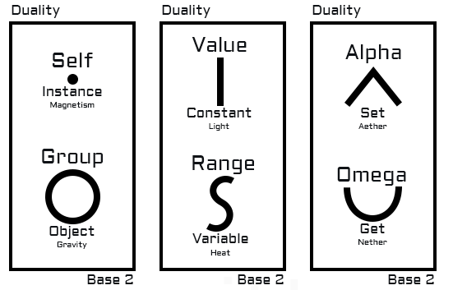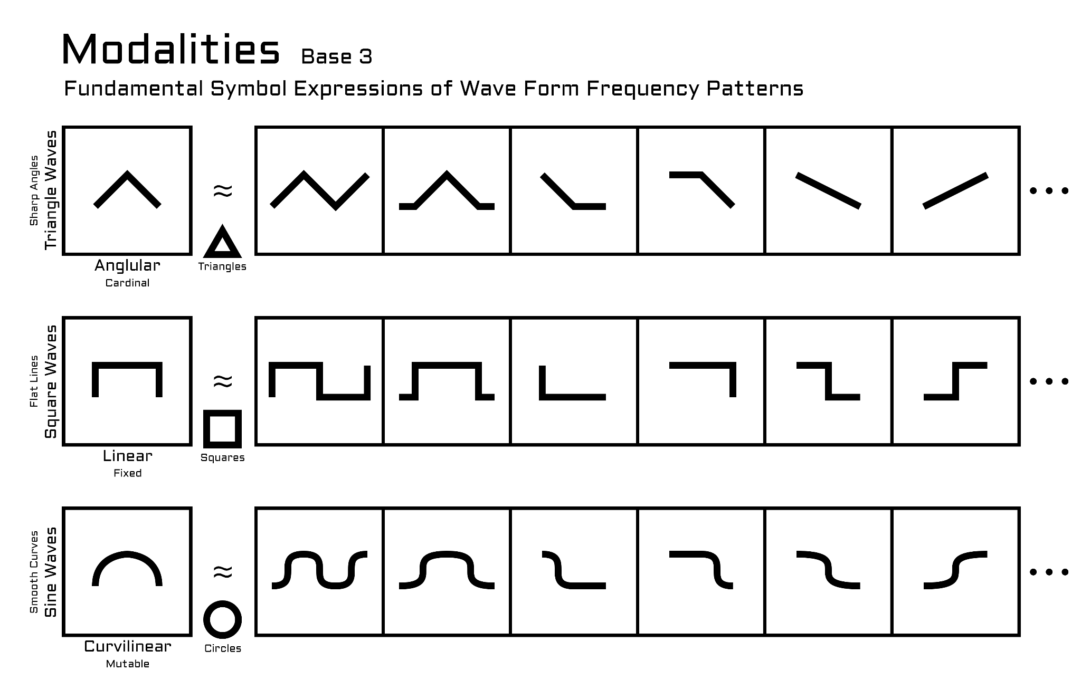

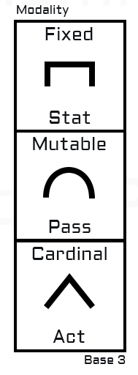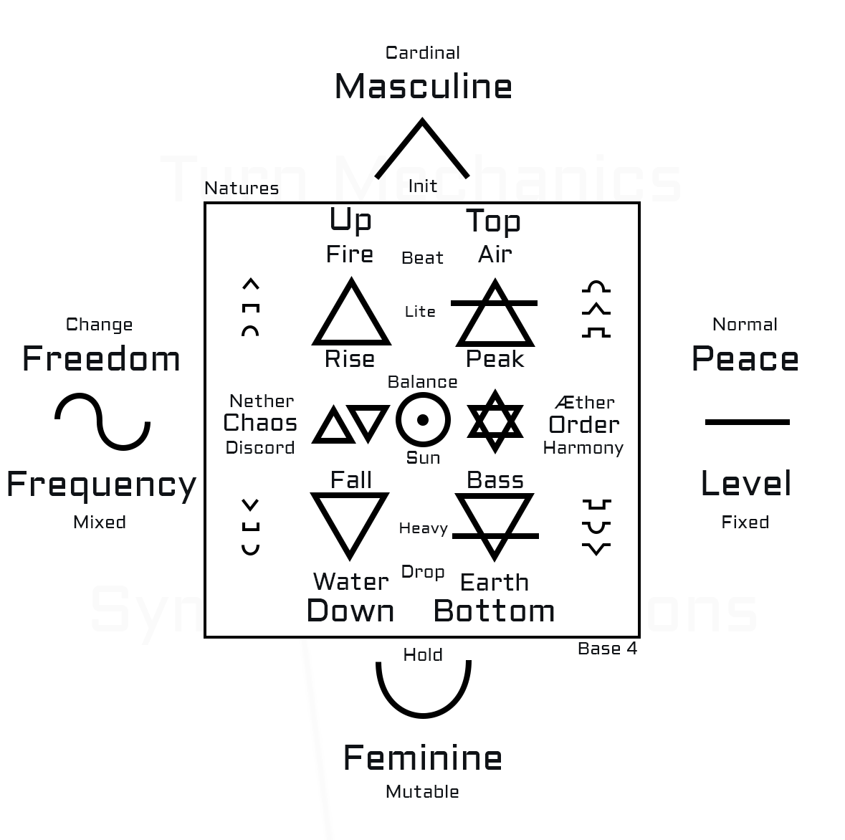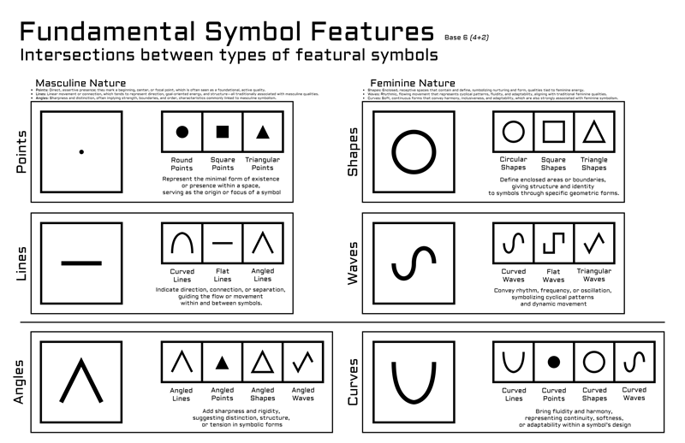

# Universal Magic - The Cosmic Cypher

Universal Language is useful for story fortelling, character generation and magic systems.

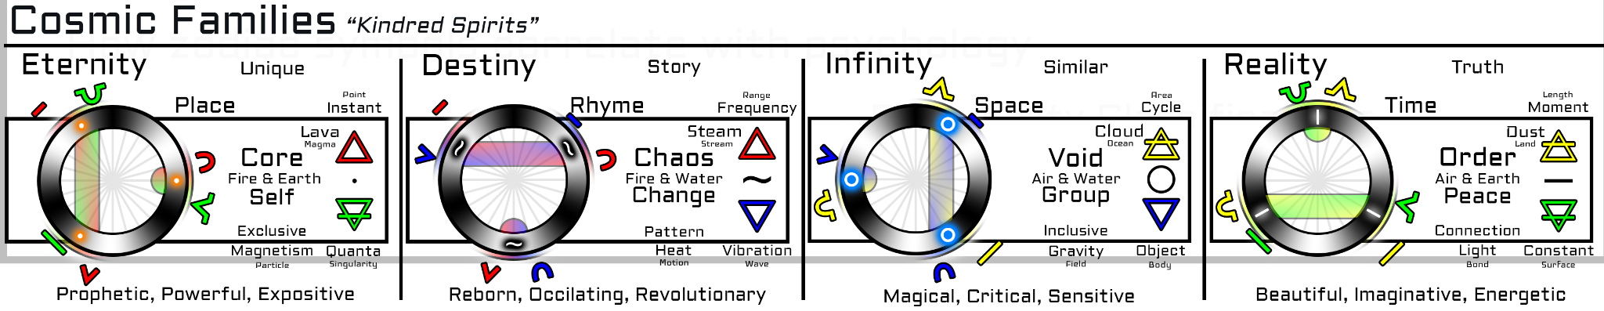

## Universal Language

Universal Language is a Quantum Language System derived from Universal Symbols.

### Proto Encryption

**Proto Encryption** refers to the logical relations between Symbolic Quanta: Universal Symbols. The relationship between symbols and symbol sets as quanta, can be used to form a singular Quantum Syntax and **Quantum Language**. Proto Encryption is an encryption language system that uses **Universal Symbology** to enable simple yet infinitely complex encryption levels.

###### “In a quantum universe, a quantum language is a universal language!” - Jono Tho’ra

#### **Puzzles!**

###### Psionic Abilities can be Unlocked by solving Proto Encryption Puzzles.

## CosmicCypher - StarDisk

##### *Unlock Cosmic Cheat Codes with Proto Encryption to use Universal Magic to Save the Future*!

Tho’ra get provisional access to cosmic energy grids when operating planet-side and in outer-space.

Universal Symbols and Subsets and Combinations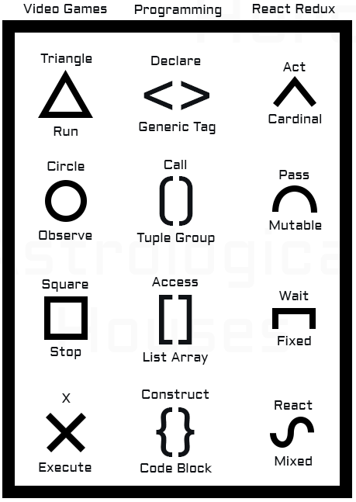

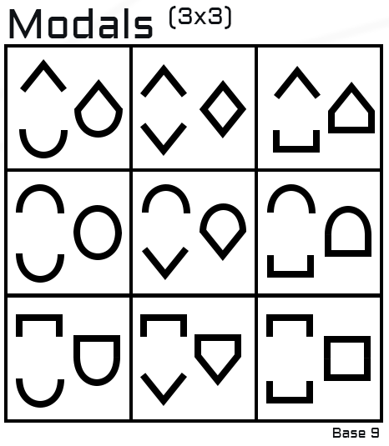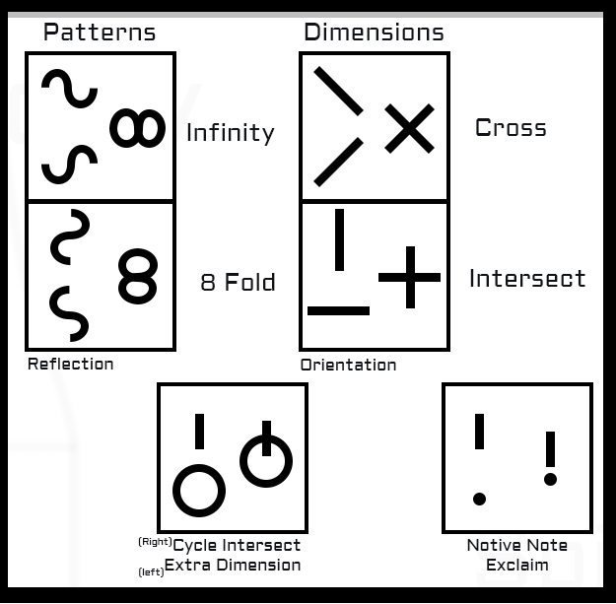

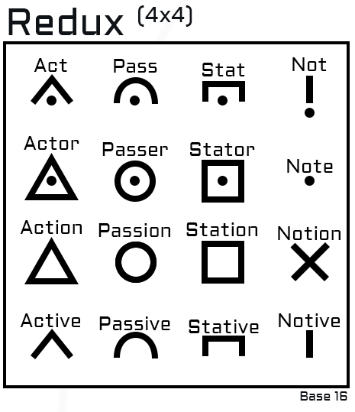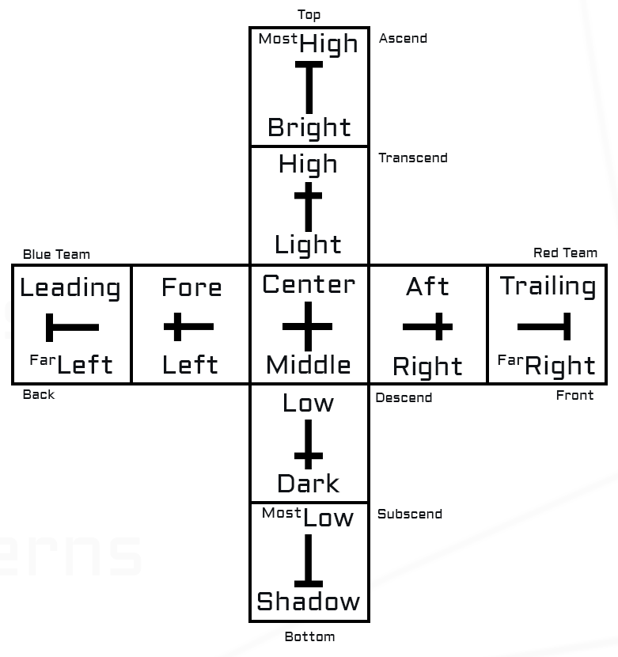

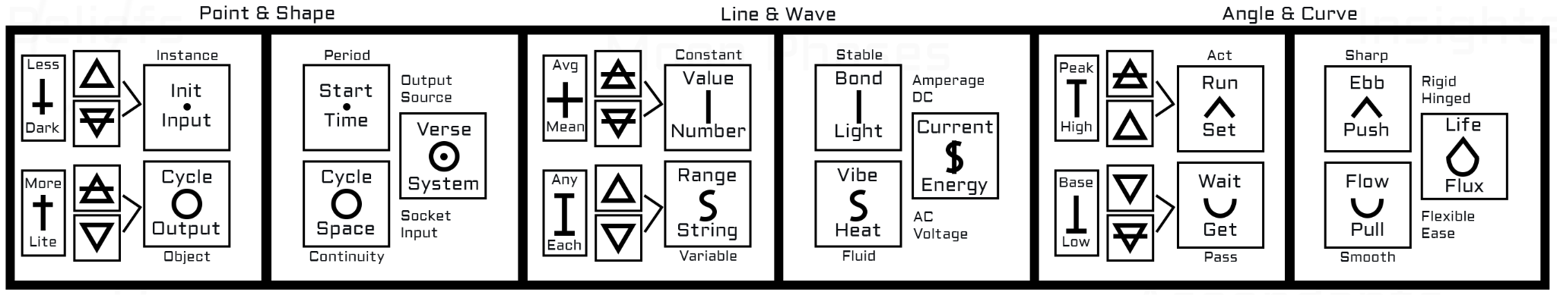

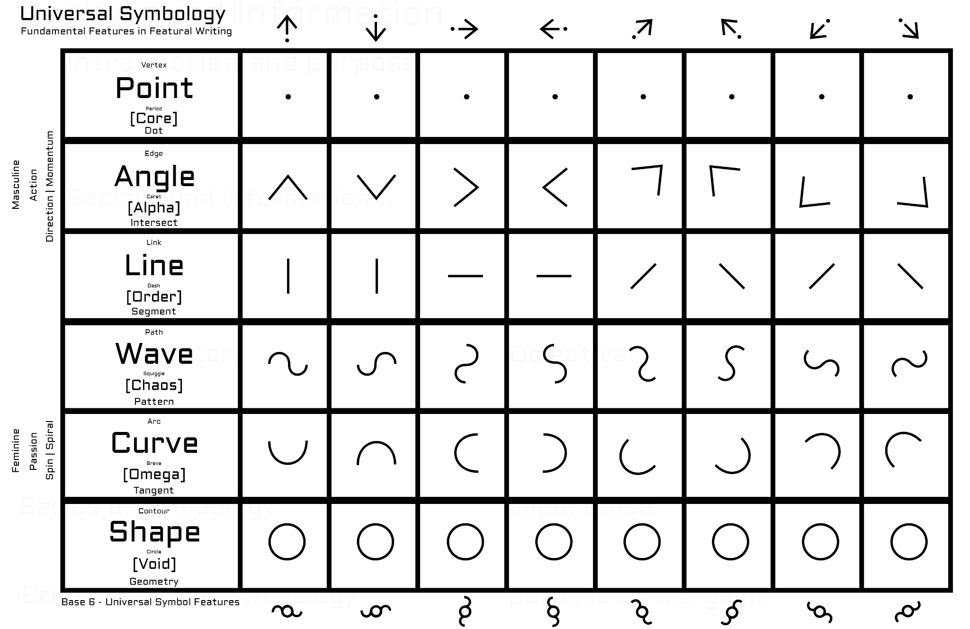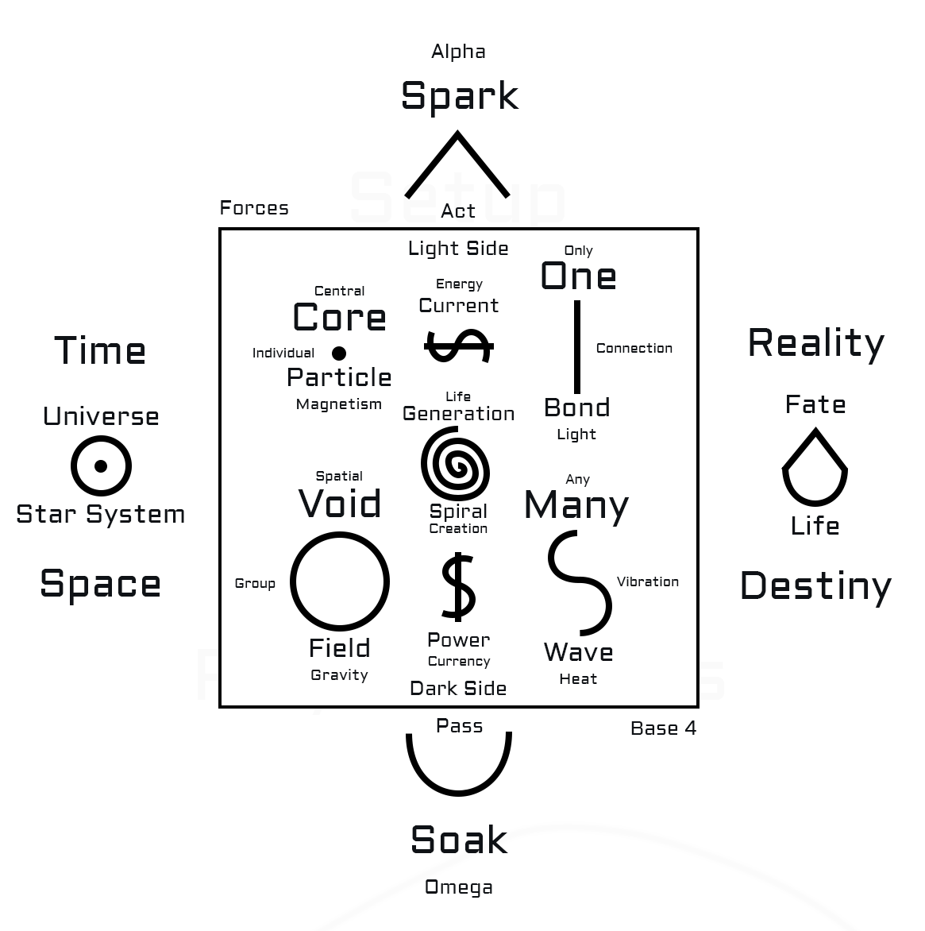

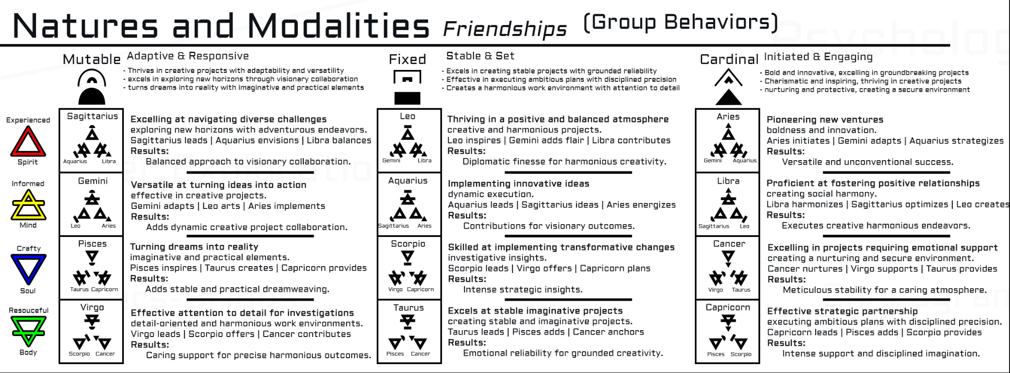

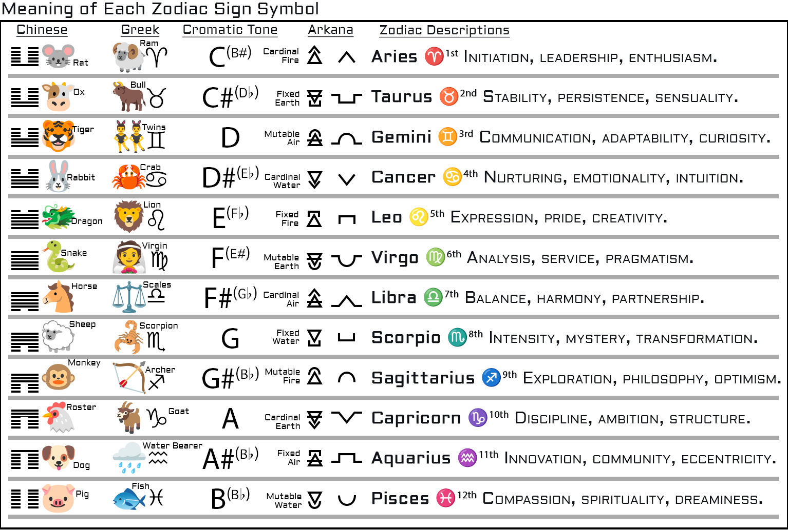

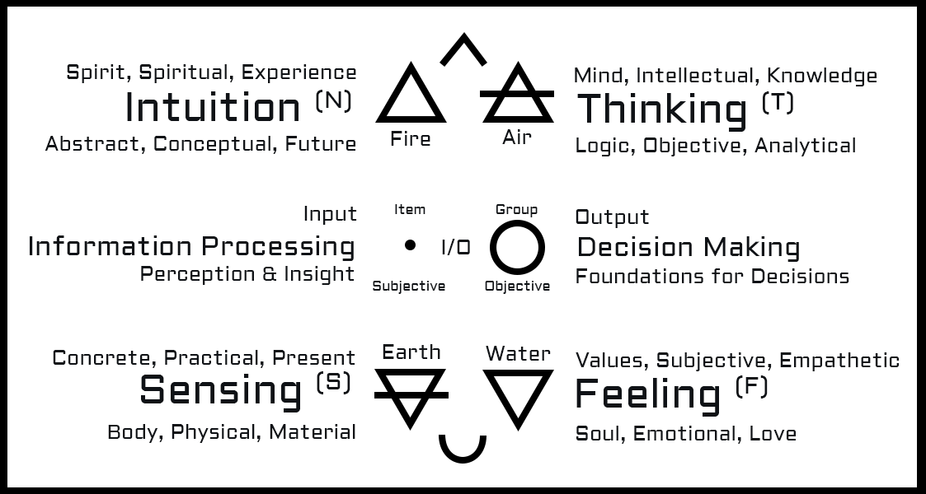

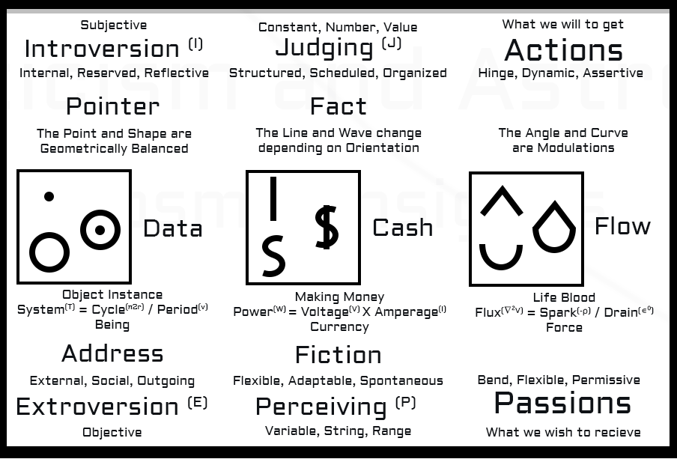

## **Modality** *(Modifier)*

| **Base Symbol** | **< ^ >** | **[ 冖 ]** | **( ⋂ )** |
| --- | --- | --- | --- |
| **Linear Geometry** | **Angle** | **Line** | **Curve** |
| **Shape** | **Triangle** | **Square** | **Circle** |
| **Waveform** | **Triangle Wave** | **Square Wave** | **Sine Wave** |
| **State** | **Active** | **Static** | **Passive** |
| **Astrology** | **Cardinal ♈♋♎♑** | **Fixed ♉♌♏♒** | **Mutable ♊♍♐♓** |
| **Astrology (desc.)** | **Dynamic** | **Stable** | **Adaptive** |
| **Alchemy** | **Sulfur 🜍** | **Salt 🜔** | **Mercury ☿** |
| **Personality** | **Leadership** | **Persistence** | **Flexibility** |
| **Development** | **Launch** | **Stabilize** | **Adjust** |
| **Race | Cycle** | **Start | Initiate** | **Middle | Sustain** | **End | Evolve** |
| **Verb | Noun** | **Act | The Action** | **Stay | The Station** | **Pass | The Passion** |
| **Interact | Move** | **Jump | Run** | **Push | Stand** | **Turn | Crawl** |
| **Flux** | **Ebb** | **Stasis** | **Flow** |
| **Quality** | **Edge** | **Flat** | **Round** |
| **Modification** | **Sharpen** | **Flatten** | **Smooth** |
| **Property** | **Sharp** | **Blunt** | **Smooth** |
| **R.P.S.** | **Scissors** | **Rock** | **Paper** |
| **Weapon | Hand** | **Blade | Chop** | **Hammer | Punch** | **Whip | Slap** |
| **Ability | Attack** | **Strike | Cut** | **Bash | Crush** | **Disarm | Stun** |
| **Defense | Defend** | **Wand | Parry** | **Shield | Block** | **Cloak | Absorb** |

| **Arcane Symbol** | **🜂** | **🜁** | **🜄** | **🜃** |
| --- | --- | --- | --- | --- |
| **Classical Element** | Fire | Air | Water | Earth |
| **Emoji | Astrology** | **🔥 | ♈♌♐** | **💨 | ♊♎♒** | **💧 | ♋♏♓** | **⛰️ | ♉♍♑** |
| **Temp | Humidity** | Hot | Wet | Hot | Dry | Cold | Wet | Cold | Dry |
| **Phase of Matter** | Plasma | Gas | Liquid | Solid |
| **Local Orientation** | Outward | Outside | Inward | Inside |
| **Vertical Position** | Up | Top | Down | Bottom |
| **Horizontal Position** | Right | Rightmost | Left | Leftmost |
| **Color** | Red | Yellow | Blue | Green |
| **Element of Art** | Line | Shape | Color | Texture |
| **Metaphysical Object** | Spirit | Mind | Soul | Body |
| **Realm** | Spiritual | Mental | Emotional | Physical |
| **Skill** | Experience | Intellect | Emotion | Resource |
| **Domain** | Activity | Community | Empathy | Practicality |
| **Quality** | Intuitive | Social | Introspective | Resourceful |
| **Life Support** | Warmth | Breathe | Drink | Food |
| **Method | Ability** | Act|Move | Think|Speak | Observe|Look | Sense|Touch |
| **Motion** | Fast | Fly | Slow | Ground |
| **Music**  **Part | Feature** | Rock  Rise | Strings | Pop  Peak | Vocals | Hip-Hop  Drop | Pipes | Classical  Bass | Drums |
| **Animal** | Lion | Eagle | Dolphin | Elephant |
| **Time of Day** | Morning | Afternoon | Evening | Night |
| **Season** | Spring | Summer | Fall | Winter |
| **Weather** | ☀️ Sunny | ☁️ Cloudy | ☔ Rainy | ❄️ Snowy |
| **Vehicle Type** | 🚀 Rocket | 🛩 Airplane | 🛥 Boat | 🚚 Truck |

# Balance Rules

## Modality Balance

### **Cardinal** beats **Mutable**

### **Mutable** beats **Fixed**

### **Fixed** beats **Cardinal**

## Nature Balance

### **Fire** beats **Air**

### **Air** beats **Water**

### **Water** beats **Earth**

### **Earth** beats **Fire**

## Cosmic Balance

### **Core** beats **Chaos**

### **Chaos** beats **Void**

### **Void** beats **Order**

### **Order** beats **Core**

## Cosmic Forces

### **Core** - Magma - Time *(Fire + Earth)*

### **Void** - Cloud - Space *(Water + Air)*

### **Order** - Dust - Reality *(Earth + Air)*

### **Chaos** - Steam - Destiny *(Fire + Water)*

### **Alpha** - Spark - Ebb *(Fire + Air)*

### **Omega** - Mud - Flow *(Water + Earth)*

## Super Cosmic Forces

### **Omni** *(Core + Void = Omniverse)*

### **Power** *(Reality + Destiny = Control)*

### **Flux** *(Ebb + Flow = Fluid)*